

Anthem WGS Transition

Application Information Document (AID)

**Individual and Small Group - Overview**

**Document ID: 002**

**Creation Date:** 2016-17-10

**Last Updated:** 2022-05-02  
**Version:** 1.0

**Status:** Draft

**Application Stakeholder Roles**

| Role | Name |
| --- | --- |
| **Authors** | |
| Deloitte LO Team |  |
| Deloitte Transition Manager |  |
| **Reviewers** | |
| Anthem - Director |  |
| Delivery Manager |  |
| Deloitte IM Area Lead (list) |  |
| **Transition Management Team Owner** | |
| Application Tech Leader |  |
| Application Development Leader |  |
| IBM Delivery Manager |  |
| Deloitte IM Area Lead (list) |  |

**Version Control**

| Version # | Date | Author(s)/Editor(s) | Description |
| --- | --- | --- | --- |
| **1.0** | 8/10/2016 | Deloitte | Draft |
|  |  |  |  |
|  |  |  |  |
|  |  |  |  |
|  |  |  |  |
|  |  |  |  |
|  |  |  |  |
|  |  |  |  |
|  |  |  |  |
|  |  |  |  |

Table of Contents

1. Objective 4

2. Terminology and Acronyms 5

3. Application Background 6

4. Application Functional Overview 7

4.1 Types of Memberships 7

4.1.1 Individual Membership 8

4.1.2 Small Group Membership 8

4.1.3 Senior Membership 9

4.2 Types of Enrollment 9

4.2.1 On-Exchange Individual Enrollment 9

4.2.2 Off-exchange Individual Enrollment 10

4.2.3 On-exchange Group Setup 10

4.2.4 Online Enrollment 10

4.2.5 Batch Enrollment 11

4.2.6 Non-ACA Enrollments 11

4.3 Line Of Business (LOB) 11

4.4 Enrollment Architecture 12

4.4.1 Pre-Enrollment 13

4.4.2 Enrollment 13

4.4.2.1 Business Process Flow 14

4.4.3 Post-Enrollment 18

5. Application Technical Overview 19

5.1 Technical Architecture 19

5.2 Environment Details 19

5.3 Databases 19

5.3.1 List of Databases 19

5.3.2 Database Layouts 20

5.3.2.1 Database Layout for Bill Entity DB 21

5.3.2.1 Database Layout for IMMMBRDB 23

5.4 Tools 25

5.5 Inbound / Outbound Feed Details 26

5.5.1 Inbound Feeds 26

5.5.2 Outbound Feeds 26

5.6 Job Flows 27

5.7 Disaster Recovery 27

6. Application Sub Domains 27

6.1 Sub Domain 1: Online Group Enrollments 27

6.2 Sub Domain 2: Online Individual Membership Enrollments 27

6.3 Sub Domain 3: Batch Group Enrollments 27

6.4 Sub Domain 4: Batch Individual Membership Enrollments 28

6.5 Sub Domain 5: Products and Rates 28

6.6 Sub Domain 6: Online Migrations, Renewals and Rate actions Group Enrollments 28

6.7 Sub Domain 7: Fulfillment 29

6.8 Sub Domain 8: Extracts and Reports 29

7. Reference 29

1. Objective

The objective of the Application Information Document (AID) is to provide an overview of the **Individual and Small Group** system (commonly known as ISG). This AID describes the architecture, function, structure, configuration, technical environment and schedule information of the application.

1. Terminology and Acronyms

Acronyms and terminology specifically used in this document are described below.

|  | **Terminology / Acronyms** | **Definition** |
| --- | --- | --- |
| 1 | MRMIP | Major Risk Medical Insurance Program |
| 2 | ISG | Individual and Small Group |
| 3 | WCF | WellPoint Common Format |
| 4 | IMS | Information Management System |
| 5 | AIM |  |
| 6 | IND | Individual |
| 7 | SG | Small Group |
| 8 | WGS | Wellpoint Group System |
| 9 | ACA | Affordable Care Act |
| 10 | WEM | Webinsure Exchange Manager |
| 11 | MAPS | Manual Application Processing System |
| 12 | MED | Medical |
| 13 | DEN | Dental |
| 14 | VIS | Vision |
| 15 | LFE | Life |
| 16 | STD | Short Term Disability |
| 17 | LTD | Long-term disability |
| 18 | WKC | Workers’ Compensation |
| 19 | E3 | Enterprise Enrollment Engine |
| 20 | E&B | Enrollment and Billing |
| 21 | WARP | WellPoint Actuarial Reporting Process |
| 22 | CIRS |  |
| 23 | CHUB | Consumer Hub |
| 24 | EMPI | Enterprise Master Person Index |
| 25 | HCID | HealthCare Identification |
| 26 | DB | Database |
| 27 | EOC | Explanation of Coverage |
| 28 | EEDI | Enterprise Electronic Data Interchange |

1. Application Background

|  |  |
| --- | --- |
| **Application**  **Background** | **Description** |
| **Overview** | **Individual and Small Group (ISG)**  ISG system is the Anthem enrollment and billing system for individuals and small groups. Its major functionality includes new enrollments, maintenance to existing enrollments, bill generation and reconcilement of payments. It receives both enrollment and payment data in Anthem Common Format (WCF) from EEDI. ISG Interfaces with all core administration systems (claims, finance, warehouse, and all downstream applications that require membership data). Enrollments can be done through batch jobs, online screens and Employer access screens.  System of record for Individual and Small Group  • Group demographics, Group Notes  • Member demographics  • Member eligibility and  • Limited Liability  ISG system can enroll both ON and OFF exchange ACA membership  Interfaces with rating system (ERE, ALPS) |
| **Business Segment** | The business segments currently supported by ISG include   * Blue Cross of California - CA * Anthem – CO and NV * Unicare – IN, IL, AR, TX, VA and MI * Seniors – WI * Transitioned business segments from Legacy systems – IN, WI, KY, MO, VA, NY, ME, CT, NH, OH |
| **Products** | * Medical – (HMO,PPO,POS, HSA) * Dental – (HMO,PPO,FFS) * Vision * EAP * Workers Comp * Life & Disability |
| **Membership Volume** | The number of active members across product entries is approximately 2 million. |
| **Account Entity Structure (Key Elements)** | Bill Entity – Represents a client |
| Membership – Store member demographic and eligibility data |

2. Application Functional Overview

In ISG application, the membership subsystem is intended to enroll members for the specified healthcare plans. Enrollment is the process of enrolling new contracts, members or dependents of existing members into the ISG Membership system. It updates the membership databases with the details of the members and sends out enrollment letters to the members. The main functions of enrollment process are:

* Enroll new members under the existing contracts in the mainframe system
* Complete a Change of Coverage
* Correct contract information (i.e. Address, Phone #, etc.)
* Cancel & reinstate contracts
* Complete a group to group transfer
* Complete a Premium Transfer to a new plan
* Correct and/or update member information (i.e. Last Name, Date-of-Birth, etc.)
* Cancel & reinstate members

ISG (Individual and Small Group) currently supports the following business segments:

* Individual
* Small Group
* Senior Medicare Supplementary Plans
* State Sponsored Business (Ex. MRMIP, AIM)

ISG Membership system is implemented on the CA mainframe and caters to Anthem’s Insurance policy holders in California, Georgia, Nevada, Wisconsin, Colorado, Kentucky, Maine, Virginia, New York, Ohio, Indiana, Connecticut, New Hampshire and Missouri. The system is built around IMS database with a few DB2 tables. The IMS database handles the major chunk of data. User interfaces are provided mainly through the IMS DC screens with some of the functionalities now being handled by Web Interfaces.

* 1. Types of Memberships

The most common types of membership enrollments in ISG, as the name suggests are:

* **Individual** (IND):
* **Small** **Group** (SG):
* **Senior Membership (SM): Senior membership is similar to Individual membership**
  + 1. Individual Membership

For an individual membership, the sponsor is the individual himself. Any subscriber within the Anthem system is identified with the help of a unique ID known as the CERT ID. A specific CERT ID may have dependents enrolled along with it. Also, the same CERT ID may be enrolled for more than one product. The below diagram depicts a sample individual membership structure.

* + 1. Small Group Membership

For a small group, the sponsor is the employer. By definition small group consists of 2-50 employees. However, this definition has changed over a period of time as some states allowed 2-100 as well into small group. Some of the membership of these groups reside in WGS as well. A small group can have multiple subscribers enrolled under it. Each of these subscribers (identified using their CERT IDs), may have dependents enrolled. Also, the same member may be enrolled for multiple products offered by the Small Group. The below diagram shows what a sample Small Group structure looks like.

* + 1. Senior Membership

For Senior (Over 65 years old), ISG offers Medicare Supplement plans. A Medicare supplement (also known as Medigap) is a state approved private medical expense insurance policy that provides reimbursement for services not covered by Medicare such as out of-pocket expenses, ( e.g., deductibles and coinsurance payments), or benefits for some medical expenses specifically excluded from Medicare coverage. Senior Enrollment is similar to Individual Enrollment.

* 1. Types of Enrollment

Based on the source of the incoming enrollments, ISG enrollments may be classified as:

1. On-exchange
2. Off-exchange
3. Non-ACA

All exchange enrollments are ACA compliant.

* + 1. On-Exchange Individual Enrollment

The following steps are followed for on-exchange enrollments

1. Individual enrolls through an Exchange
2. Exchange passes on member data to pre-enrollment system
3. Pre-enrollment system will release enrollment files to ISG only when initial payment is received.
4. Pre-enrollment system passes enrollment data to ISG
5. Once payment is received, payment and enrollment information is matched and the member is enrolled.
6. Enrollment acknowledgement, ID card information etc. are sent back to exchange.
   * 1. Off-exchange Individual Enrollment

The following steps are followed for off-exchange enrollments:

1. Paper application fed into MAPS.
2. MAPS sends individual information to WEM.
3. WEM matches the payment and enrollment information and forwards the data to ISG.
4. ISG completes the enrollment.
   * 1. On-exchange Group Setup
5. Public exchanges send group information to WEM in the form of an xml file.
6. WEM sends the data to ISG.
7. ISG automatically sets up the group using the information in the xml file and sends back an acknowledgement to WEM. In case, the automated group setup in ISG fails, the group is setup manually and the acknowledgement is sent to WEM.
8. WEM sends an acknowledgement to the public exchange that a group has been setup and member enrollment may begin.

Based on how member enrollment information is fed into ISG, enrollments can be classified as:

* Online Enrollment
* Batch Enrollment
  + 1. Online Enrollment

Online enrollment is done with the help of online screens (also known as green screens) where member information is manually entered. Given below is the online enrollment process flow:

1. Applicant completes the Individual Membership application with or without the help of a broker and sends it with initial premium payment/credit card information/bank account information to the health insurance provider
2. Application is received by the Individual Shared Services Department where it is scanned, turned into a work item and routed systematically to the Underwriting System.
3. If any information is missing, it will be obtained from the subscriber. It also reviews all of the Health History of the applicant.
4. Once the application is approved, it is routed to the Individual Membership New Applications Queue.
5. For online enrollment, the details are sent from the Underwriting System to the users.
6. A member enrolled as an individual can choose from a plethora of products available and may be enrolled under multiple products.
7. Members enrolled under a group can only choose amongst the products available for that group. Also, for enrollment into Small Groups, the group needs to be setup prior to any member enrollment.
   * 1. Batch Enrollment

* Batch Enrollments are done for applications that are submitted to E3 through exchanges and other Anthem channels like Shopper Portal and MAPS.
* E3 processes the applications and sends automated communication to customers/brokers if initial payment is needed.
* Once validations like whether the applicant is covered in our service area etc. have been performed, the applications are sent to ISG. ISG then enrolls the members through batch programs.
  + 1. Non-ACA Enrollments

<Content>

* 1. Line Of Business (LOB)
* The Line of Business (LOB) is a set of products that have similar characteristics. One example of an LOB would be medical. Some products within the medical line of business could be HMOs, PPOs and FFS organizations.
* A product refers to the kind of coverage that will be offered by the groups that contain that product. Medical, Vision and Dental are examples of products.
* Coverage combines a line of business with a “brand” such as Unicare, Blue Cross of California etc. and a network plan configuration such as HMO, PPO, FFS (Fee for Service), etc.
* Examples of product lines include Unicare HMO Medical, Unicare PPO Medical, and Blue Cross of California Fee for Service, Blue Cross Blue Shield of Colorado Medicare Part D Standalone, etc.
* There are multiple products that are supported by ISG:
  + Medical (MED)
  + Dental (DEN)
  + Vision (VIS)
  + Life (LFE)
  + STD (Short-term disability - For Small Group only)
  + LTD (Long-term disability - For Small Group only)
  + WKC (Workers’ Compensation - For Small Group only)
* The below diagram is a pictorial representation of the components of a product:
  1. 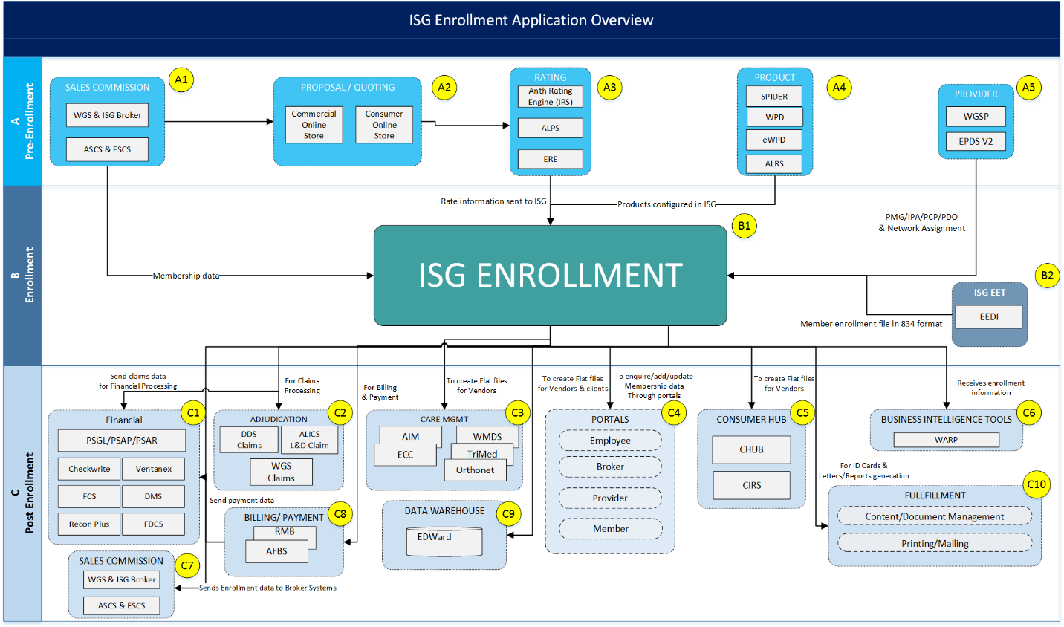Enrollment Architecture

The diagram depicts the interaction of ISG Enrollment and Billing (E&B) applications with the pre-enrollment and post-enrollment systems / entities. E&B constitutes both WGS and ISG applications. This document will discuss the ISG module in detail.

* There are many external components that interact with E&B application. Predominantly, public exchanges, private exchanges, payment modules etc. Most of the external applications are third party software which perform specific business activity.
* Anthem houses numerous in-house and acquired applications which interact with the E&B application. They can be categorized into Pre-enrollment and Post-enrollment systems.
  + 1. Pre-Enrollment
  1. **Sales Commission**: This module houses the ISG and WGS broker applications. It involves payment to Brokers and agents based on the enrollment information obtained from E&B.
  2. **Proposal and quoting**: This doesn’t have a direct interaction with ISG module per se. However, Consumer and Commercial online store interacts with ISG broker to get information on how rating has to be done to a newly set up group on ISG.
  3. **Product / Rating**: This is a key application that interacts with the E&B module. It houses all the product information which is used during enrollment where the members/ subscribers are provided product and network information from these systems. SPIDER interacts heavily with ISG application.
  4. **Provider**: Provider module provides doctor, hospitals and other provider related information to ISG so that the network of providers can be established in a plan and claims can be adjudicated accordingly.
     1. Enrollment
* The ISG system interfaces with the Underwriting, Broker and the EMPI West systems (Enterprise Master Person Index – An external system for generating the HCID) for the enrollment function. Underwriting system is responsible for scrutinizing the applications received and ensures that all relevant data related to the subscriber and their health history is correct.
* Since HIPAA rule requires that the subscriber SSN should not be used in any of the correspondence with the customer, the EMPI system was set up to generate a unique number – the HCID, based on the subscribers ID which can be his SSN or Enrollment ID.
* In addition to replacing the SSN with an HCID, EMPI links a member's records in more than one membership system by assigning them one unique HCID across all systems, thus providing a 360 degree customer view. Enrollments can be done through batch jobs, online screens and Employer access screens.
  + - 1. Business Process Flow



**ID card Processing**

* An identification card (ID card) is a card issued to the subscriber and/or dependents, which allows the members to identify themselves or their covered dependents to a provider for health care services. The card is used by the provider to determine benefit levels. Request to create ID Cards and Spec Pages are automatically triggered by the online transactions as well as some batch processes.
* ID Cards can also be requested manually using online screen as per the requirement. ID Cards are generated automatically, after the member has been enrolled, or if there is a Change of Name or change of HMO Provider or from the Provider rollover job. These files are sent to the ID card vendors to create the ID cards and mail it to the subscribers.

**Billing**

* Billing Function: Since ISG houses both Individual as well as Small Group Members, separate set of billing processes are implemented to bill members who fall under these categories. Billing processes invoices. The calculation of premium is based on the members’ Product group rates and the reconciliation of the premium payment received.
* ISG uses the following billing frequencies:
* 1- Monthly
* 2- Bimonthly
* 4- Quarterly
* 6- One-time credit card
* 7- Recurring credit card
* 9- Auto-deduction
* A- Annual (for senior business)
* Bi- Biannual (for senior business)

**Lock box processing**

* Lockbox is a service offered by banks to companies in which the company receives payments by mail to a post office box and the bank picks up the payments several times a day, deposits them into the company's account and notifies the company of the deposit.
* This enables the company to put the money to work as soon as it is received, but the amounts must be large in order for the value obtained to exceed the cost of the service.

**Rate renewal and Pre-pass**

* Rate renewing is a process of changing the premium amount. Rate renewing is applicable for small groups and individuals.

**Underwriting and Broker System**

* Underwriting is the process of identifying and classifying the degree of risk represented by a proposed insured. The Underwriting Department is responsible for enrolling all new groups with Blue Cross. The U/W Status or the Underwriting Status indicates the standing of the group in Underwriting. Ex. A Status code ‘A’ indicates that the group is approved. The status code ‘P’ indicates that the group is pending approval from the Underwriting Dept.

**Broker**

* Broker is a sales agent who is under contract and sells the insurance products of more than one insurance company. An agent is a person or entity who helps employers or Individuals obtain insurance coverage. Agents are also referred to as Brokers.
* Broker information is used on UNICARE’s Individual and Small Group business. ISG Broker contains the interfaces to/from the ISG Membership System application along with the type of information being passed. The inbound information passed is agent data and the outbound information passed is eligibility data.

**CALCOBRA Billing**

* The state of California created Cal-COBRA, effective from January 1, 1997, to specifically address the needs of those smaller groups that do not meet the requirements of federal COBRA, which are those that had 20 or more employees for at least 50% of the previous calendar year.
* Coverage through Cal COBRA is the same principle as federal COBRA, except that it is for members of groups that have employed between 2-19 employees for at least 50% of the previous calendar year. The qualifying events and election timelines are identical to that of federal COBRA with a few significant exceptions.
* The two qualifying events for subscribers to be eligible for Cal COBRA and four events that allow continuation for dependents are mentioned below. Also included, in parenthesis, is the maximum period those members would be allowed to have Cal COBRA, based on the given qualifying events.
  + Subscribers (18 months)
* Termination of employment
* Reduction of hours
  + Dependents (36 months)
* Death of subscriber
* Divorce or legal separation from subscriber
* Subscriber is eligible for Medicare
* Over-age dependent loses dependent status
* If a person leaves the company, he/she can still continue with same medical plan. In state of California, the person is billed separately as an individual even though he/she is within the company plan. Usually, the member would pay a higher premium if being billed under CALCOBRA. The first letter of ‘C’ in the certificate identifies a CALCOBRA member.

**Bank Draft flow**

* Bank Draft is one of the modes of premium payment for the subscriber. The other modes of payment are through Checks and Credit Cards. Bank draft allow member to pay premium automatically through their bank account. If subscriber wants to add a bank draft to existing policy, he has to provide a request that includes bank and account details.

The following criteria should be met for adding a bank draft

* Group must be in pend bill.
* No outstanding fee or adjustments
* No premium in unprocessed cash
* Reverse receivable for adding bank draft.
* Bill frequency will determine the bill type or method in which subscriber wants to be billed.
* Bill frequency = 9, policy is already on a bank draft
* Bill frequency = 4, policy is not on a bank draft, rather billed quarterly.
* Health Check processing is run once a month and creates vouchers that will be used to pay off the bills created by the Health Check processing.
* This process was set up a long time ago to be able to draw money from each subscriber checking account called Bank Draft processing if they had enrolled for Health Check. In this way, the subscriber pays for their coverage without having to send a check into the bank. The actual draw that is done once a month is listed on the subscriber’s checking account statement each month by the bank.

**WARP**

* WARP is “WellPoint Actuarial Reporting Process”. WARP is a process used for collecting and storing membership data. Actuarial Finance uses it to report Membership enrollment to Wall Street.
* WARP is a single source of data for WellPoint actuaries in support of common actuarial functions. It has well documented data definitions and reconciled data. Data supported by WARP is homogeneous (uniform in structure and definition) in nature, complete, accurate, in balance, timely and submitted in a standard format from all the systems. To ensure data quality, edits are performed on all incoming fields. Two levels of errors are usually identified
  + Fatal - on critical data elements, e.g., LOB; and
  + Dirty - non-critical data, e.g., invalid Gender code
* Fatal errors will stop processing of the file. A report of all incorrect data will be sent back to the submitting source system in order for them to monitor the quality of and correct their data. It is expected that situations creating dirty data will be corrected prior to the next month end cycle.

**Files sent and received from NSF, Ventanex, ESI, COBC, Pharmacy etc.**

* NSF, Pharmacy, Ventanex, ESI, MSP, COBC and data warehousing are external areas or applications. Whenever any changes are applied to membership (like new member, member change, member terminated) the information’s are send to pharmacy, ESI. MSP and COBC.

**Lumenos and its interface with Core Membership**

Lumenos is an affiliate of Anthem Blue Cross of California specializing in providing Anthem’s CDHP suite of products.

* + 1. Post-Enrollment

1. **Financial System**: For group set up, we need financial information. Finance team obtains information regarding payment of the member from exchanges and based on the response, member is enrolled / cancelled.
2. **Adjudication**: This is the crux of healthcare. Claims and Membership are closely coupled. Any changes in the membership needs to be communicated to claims module at runtime. Claims applications for Adjudication interact with ISG to obtain membership information for processing claims.
3. **Care Management**: Member information is sent to care management
4. **Shared Services**: E&B also interacts with the following Customer Service applications:
   1. **Employer** **Portals**: Portal for employers to login and check the status of their bill entity. This portal supports the enrollment and billing of the employer.
   2. **Broker Portals**: This portal is meant for the broker and agent who help sell Anthem products to the customers.
   3. **Provider Portals**: This portal is for the providers, doctors to verify and see the payment information.
   4. **Member Portals:** Members can login to the portal, see their certificates, Claims information etc. There is also a dedicated mobile app to serve this purpose.
5. **Consumer Hubs** (CHUB and CIRS) store consumer information.
6. **WARP**: Stands for “WellPoint Actuarial Reporting Process”. WARP is used for collecting and storing membership data. Actuarial Finance uses it to report Membership enrollment. It provides the data for corporate financial analysis purposes, as well as for reporting sales, terminations, lapses and persistency/retention. This corporate membership data is critical to business and is reported to key external constituents, as well as to the board of directors and executive management.
7. **Billing system** focuses on premium calculation, invoice generation etc. Although ISG has a billing application, for certain functions interfacing with other billing systems in Anthem might be required.
8. **EDWard** is the data warehouse used for storing data for reporting etc.
9. **Fulfillment** systems manage fulfillment data and functions like EOC, letters that may be reviewed by users online, welcome kits, etc.

1. Application Technical Overview
   1. ISG Environment Details

|  |  |  |  |  |  |
| --- | --- | --- | --- | --- | --- |
| **TSO** | **DB2 Region** | **DB2 Table Creator Name** | **IMS Online Region** | **SYSTEM** | **Channel** |
| TSOS | DB2P | UCPROD | IMSP | B |  |
| TSOA | DB2T | UCTEST | IMST | C |  |
| DB2Q | UCUSER | IMSN | C |  |
|  | UCACPT | IMSA | C | IMSA |
| DBT1 | UBR | IMT1 | C |  |
| DBT2 | UBR | IMT2 | C |  |
| DBT3 | UBR | IMT3 | C |  |
| DBT4 | UBR | IMT4 | C |  |
| TSOD | DB2W | UBR | IMSW | D |  |
| DBW1 | UBR | IMW1 | D |  |
| DBW2 | UBR | IMW2 | D |  |
| DBW3 | UBR | IMW3 | D |  |
| DBW4 | UBR | IMW4 | D |  |

* 1. Databases
     1. List of ISG Databases

The list of ISG databases and their descriptions are given below:

|  |  |  |
| --- | --- | --- |
| **S.No.** | **Database** | **Description** |
|  | IMMACTDB | Accounting Database |
|  | IMMADJDB | Billing Adjustments Database |
|  | IMMAUDDB | Audit Trail Database |
|  | IMMBNTDB | Bill Entity Database |
|  | IMMBSMDB | Billing Summary Database |
|  | IMMBTRDB | Stores BTTR triggers for online transactions |
|  | IMMBWKDB | Bill Work Database |
|  | IMMCBHDB | Cash Batch through LOCKBOX |
|  | IMMCDTDB | Cash Detail(Vouchers) |
|  | IMMCIPDB | ISG Navigation Work Database |
|  | IMMCUQDB | Unprocessed Cash/Cash Inquiry Database |
|  | IMMEETDB | Electronic Enrollment transmission Database |
|  | IMMEHTDB | EET History Database |
|  | IMMFINDB | Financial/Billing Individual & Senior |
|  | IMMGPNDB | Group Name Database |
|  | IMMGPRDB | Group Rate Database |
|  | IMMGPSDB | Group Status Database (Group Name & Group Member) |
|  | IMMGRBDB | Group Bill Database |
|  | IMMGSMDB | Group Status & Membership (Logical Database) |
|  | IMMINVDB | Bill Invoice Database |
|  | IMMLSTDB | Summary Bill/List Bill Database |
|  | IMMMBRDB | Membership Database |
|  | IMMMGTDB | Management Area Database |
|  | IMMMMGLD | Membership & Group Status (logical Database) |
|  | IMMNAVDB | ISG Navigation Database |
|  | IMMRTDDB | Rate Guarantee Database |
|  | IMMTBLDB | Table Segment Database |
|  | IMMTBLOF | HISAM overflow for IMMTBLDB |
|  | IMMWK1DB, IMMWK2DB, IMMWP1DB, IMMWP2DB | Work Database |

* + 1. Database Layouts

The database layouts for the primary ISG DBs are given below:

* + - 1. Database Layout for Bill Entity DB

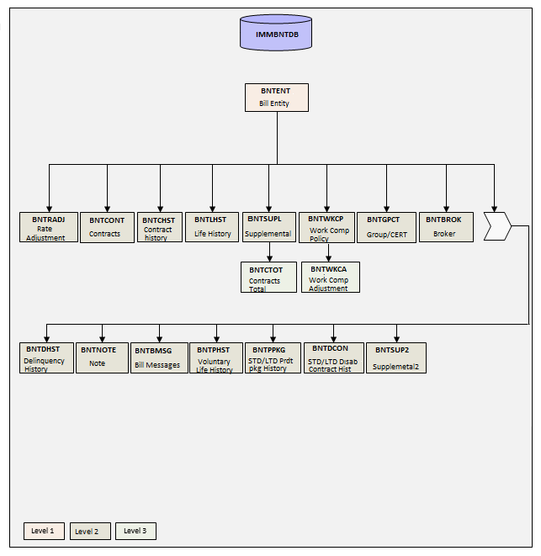

| **Segment** | **Description** | **Layout** |
| --- | --- | --- |
| BNTENT | Bill entity | IMMENTRC |
| BNTRADJ | Rate Adjustment | IMMRADJC |
| BNTCONT | Contracts | IMMCONTC |
| BNTCHST | Contract History | IMMCHSTC |
| BNTLHST | Life History | IMMLHSTC |
| BNTSUPL | Supplemental | IMMSUPLC |
| BNTCTOT | Contracts Total | IMMCTOTC |
| BNTWKCP | Work Comp Policy | IMMWKCPC |
| BNTWKCA | Work Comp Adjustment | IMMWKCAC |
| BNTGPCT | Group/Cert | IMMGPCTC |
| BNTBROK | Broker | IMMBROKC |
| BNTDHST | Delinquency History | IMMDHSTC |
| BNTNOTE | Note | IMMNOTEC |
| BNTBMSG | Bill Messages | IMMEMSGC |
| BNTPHST | Voluntary Life History | IMMPHSTC |
| BNTPPKG | STD/LTD Product Package History | IMMPPKGC |
| BNTDCON | STD/LTD Disab Contract History | IMMDCONC |
| BNTSUP2 | Supplemental2 | IMMSUP2C |

* + - 1. Database Layout for IMMMBRDB

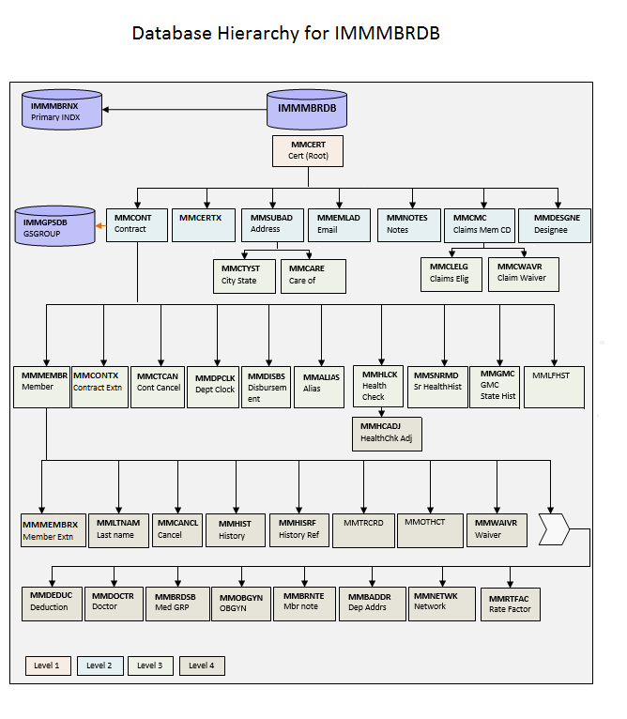

This is one of the main IMS database in ISG Membership. The Individual CERT number (9 byte) is the key field of the root segment MMCERT. MMCONT is the contract segment under the MMCERT and 6 byte Product Group number is the key field.

| **Segment** | **Description** | **Layout** |
| --- | --- | --- |
| MMCERT | Cert | MMCERTC |
| MMCONT | Contract | MMCONTC |
| MMMEMBR | Member | MMMEMBRC |
| MMLTNAM | LastName | MMLTNAMC |
| MMCANCL | Cancel | MMCANCLC |
| MMHIST | History | MMHISTC |
| MMHISRF | History Reference | MMHISRFC |
| MMTRCRD | MemXfer Credit | MMTRCRDC |
| MMOTHCT | Other Certificate | MMOTHCTC |
| MMWAIVR | Waiver | MMWAIVRC |
| MMDEDUC | Deduction | MMDEDUCC |
| MMDOCTR | Doctor | MMDOCTRC |
| MMBRDSB | Mem Med Group | YMBDSBC |
| MMOBGYN | OBGYN | YMMOBGC |
| MMBRNTE | Member note | YMMBRNTC |
| MMBADDR | DependentAddr | IMMBADRC |
| MMNETWK | Network | YMMNTWKC |
| MMRTFAC | RateFactor | IMMRTFAC |
| MMCTCAN | ContractCancel | MMCTCANC |
| MMDPCLK | Dept Clock | MMDPCLKC |
| MMDISBS | Disbursement | MMDISBC |
| MMALIAS | Alias | MMALIASC |
| MMHLCK | HealthCheck | MMHLCKC |
| MMHCADJ | HealthCkAdjust | YMHCADJC |
| MMSNRMD | Sr Health Hist | YMMSNRC |
| MMGMC | GMC State hist | YMMGMCC |
| MMLFHST | MemlifeHistory | YMMLHSTC |
| MMSUBAD | SubscrAddress | MMSUBADC |
| MMCTYST | CityState | MMCTYSTC |
| MMCARE | Care Of | MMCAREC |

* 1. Tools

|  |  |  |
| --- | --- | --- |
| **Sl No** | **Tools** | **Description** |
| 1 | ChangeMan | Version Controller |
| 3 | Debug Tool | Tool used for Mainframe code debugging |
| 4 | SPUFI | SQL Processing Using File Input for running DB2 queries |
| 5 | Fault Analyzer | Tool used to check Abends |
| 6 | FM-IMS/DB2 | File Manager tool to Access IMS /DB2 Database |
| 7 | IOF | Interactive Output Facility – A TSO program for monitoring and processing job and sysout datasets |
| 8 | SAR | Sysout archival and retrieval system for storing and retrieving mainframe job output |
| 9 | Tablebase | In-memory table management solution for mainframes |
| 10 | Control-M | Job Scheduler |

* 1. Inbound / Outbound Feed Details
     1. Inbound Feeds

|  |  |  |
| --- | --- | --- |
| **Sl NO** | **Inbound Interface** | **Information Passed** |
| 1 | ISG Medical Underwriting System | New eligibility data |
| 2 | Corporate Lockbox System | Payments information |
| 3 | Bank of America | NSF data |
| 4 | Workers Compensation | Policy data |
| 5 | State of California | New eligibility data |
| 6 | ISG Claims Contract Profile | Benefit data |

* + 1. Outbound Feeds

|  |  |  |
| --- | --- | --- |
| **Sl No.** | **Outbound Interface** | **Information Passed** |
| 1 | Pharmacy | Eligibility data |
| 2 | Capitation | Eligibility data |
| 3 | WARP | Eligibility data |
| 4 | WDS (Dental) | Eligibility data |
| 5 | General Ledger | Financial data |
| 6 | Workers Compensation | Eligibility data |
| 7 | Check Write | Refund data |
| 8 | Corporate EIS | Eligibility data |
| 9 | Periodic Extracts | Eligibility data, financial data for reporting |
| 10 | ISG Claims System | Eligibility data |
| 11 | LITES | Eligibility data |

* 1. Disaster Recovery
  2. Job Flows

1. Application Sub Domains

ISG has 4 lines of business. Individual, Small Group, Senior Medicare Supplementary Plans and State Sponsored Business (Ex. MRMIP, AIM). In order to describe and understand the system better, ISG is divided into the following subdomains:

1. Online Group Enrollments
2. Online Individual Membership Enrollments
3. Batch Group Membership Enrollments
4. Batch Individual Membership Enrollments
5. Products and Rates
6. Migrations & Renewals and Rate actions
7. Fulfillment (ID Cards, Letters, EOCs etc.)
8. Extracts and Reports (Balance and Controls, etc.)

Each of the sub domains are explained in detail in the below sections. The links in the sub domains is directed to a dedicated document specific for the sub domain.

* 1. Sub Domain 1: Online Group Enrollments

Detailed information about different ISG Products and rates can be found at: AID – Online Group Enrollments

* 1. Sub Domain 2: Online Individual Membership Enrollments

Detailed information about different ISG Products and rates can be found at: [AID - ISG Products and Rates](https://wgsmodernization.atlassian.net/wiki/download/attachments/33947734/AID%20Products%20and%20Rates%2009272016.docx?api=v2)

* 1. Sub Domain 3: Batch Group Enrollments

Detailed information about different ISG Products and rates can be found at: [AID - ISG Products and Rates](https://wgsmodernization.atlassian.net/wiki/download/attachments/33947734/AID%20Products%20and%20Rates%2009272016.docx?api=v2)

* 1. Sub Domain 4: Batch Individual Membership Enrollments

Detailed information about different ISG Products and rates can be found at: [AID - ISG Products and Rates](https://wgsmodernization.atlassian.net/wiki/download/attachments/33947734/AID%20Products%20and%20Rates%2009272016.docx?api=v2)

* 1. Sub Domain 5: Products and Rates

A product is a combination of services and aids provided to a person who chooses to enroll for them (Eg:- medical, dental, vision, etc.). These benefits, in essence, “insure” the member against any medical eventualities that fall under the services decided prior to the enrollment.

Rates are contractual premium values that the subscriber agrees to pay for the products he/she enrolls for. Rates are guaranteed and cannot be changed for a defined period of time (Rate guarantee period) unless there is a change in benefits, demographics, etc.

Detailed information about different ISG Products and rates can be found at: [AID - ISG Products and Rates](https://wgsmodernization.atlassian.net/wiki/download/attachments/33947734/AID%20Products%20and%20Rates%2009272016.docx?api=v2)

* 1. Sub Domain 6: Online Migrations, Renewals and Rate actions Group Enrollments

Migration is a process to transition Individual and Small Group membership to off-exchange HCR compliant ISG products, with the key goal of retaining existing Individual and Small Group book of business.

Renewals is a process to transition the Individual or Small group memebers from current plans to next year’s ACA/Non-ACA plans. Renewals can be categorized as:

* On-exchange
* Off-exchange.

Each of On-exchange and off-exchange renewals can be categorized as:

* Non-ACA to ACA
* ACA to ACA

Rate actions are used to notify the Individual subscribers of rate changes or benefit modifications. They are applicable to both the legacy as well as ACA products.

Detailed information about Online Migrations, Renewals and Rate actions can be found at: [AID - Online Migrations, Renewals and Rate Actions](https://wgsmodernization.atlassian.net/wiki/download/attachments/33947734/AID%20Migrations%20Renewals%20and%20Rate%20Actions%2009232016.docx?api=v2)

* 1. Sub Domain 7: Fulfillment

Fulfillments can be of three types – ID Cards, EOCs and Welcome Kits.

An Identification card (ID card) is a card issued to the subscriber and/or dependents, which allow the members to identify themselves and their dependents to a provider for health care services.

An Explanation of Coverage (EOC) is a statement sent by a health insurance company to covered individuals explaning what medical treatments and/or services were paid for on their behalf.

A Welcome Kit is a standard user guide and list of documents that a subscriber must familiarize themselves with, when enrolled in a health plan.

Detailed information about these three types of Fulfillments in ISG can be found at: [AID - ISG Fulfillment](https://wgsmodernization.atlassian.net/wiki/download/attachments/33947734/AID%20ISG%20Fulfillment%2010052016.docx?api=v2)

* 1. Sub Domain 8: Extracts and Reports

Detailed information about different ISG Products and rates can be found at: [AID - ISG Products and Rates](https://wgsmodernization.atlassian.net/wiki/download/attachments/33947734/AID%20Products%20and%20Rates%2009272016.docx?api=v2)

1. Reference